Oberon Ilano

CS 447

Final Project

**1.**

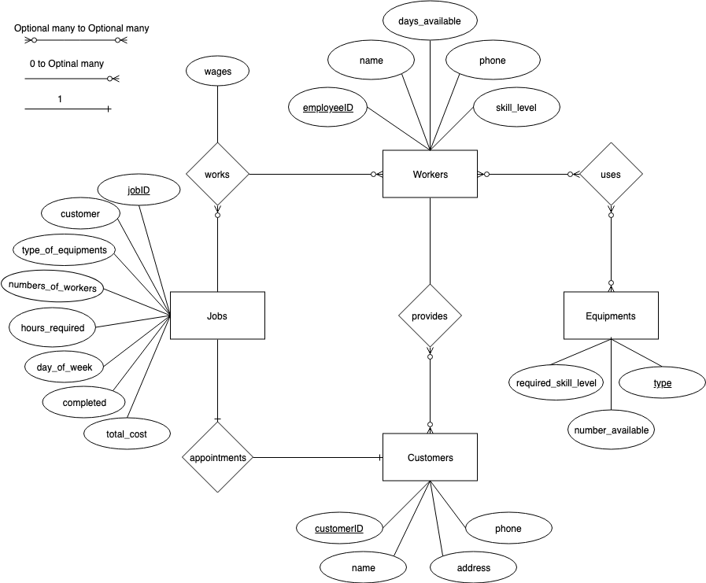

Entities:

Workers(employeeID, name, days_available, phone, skill_level)

Equipments(type, number_available, required_skill_level)

Customers(customerID, name, address, phone)

Jobs(jobID, customer_name, type_of_equipment, numbers_of_workers, hours_required, day_of_week, completed, total_cost)

Relationships:

works(employeeID, jobID, wages)

appointments(jobID, customerID)

provides(employeeID, customerID)

uses(employeeID, EquipmentType)

**2.**

All relations are already in BCNF since there is no partial dependencies, no transitive dependencies, and the attributes are atomic. The functional dependencies fulfil the condition X → Y, where X is the superkey of the relations deriving the whole relation.

***Entities***

Workers:

employeeID $→$ name, days_available, phone, skill_level

employeeID $→$ skill_level

employeeID $→$ phone

employeeID $→$ name

employeeID $→$ days_available

Equipments:

type $→$ number_available, required_skill_level

type $→$ number_available

type $→$ required_skill_level

Customers:

customerID $→$ name, address, phone

customerID $→$ name

customerID $→$ address

customerID $→$ phone

Jobs:

jobID $→$ customerName, type_of_equipment, numbers_of_workers, hours_required, day_of_week, completed, total_cost

jobID $→$ customer_name

jobID $→$ type

jobID $→$ type_of_equipment

jobID $→$ numbers_of_workers

jobID $→$ hours_required

jobID $→$ day_of_week

jobID $→$ completed

jobID $→$ total_cost

***Relationships***

works:

employeeID $→$ customerID, wages

employeeID $→$ customerID

employeeID $→$ wages

appointments:

jobID $→$ customerID

provides:

employeeID $→$ customerID

uses:

employeeID $→$ EquipmentType

**3.**



Workers:

CREATE TABLE Workers(employeeID int PRIMARY KEY

NOT NULL AUTO_INCREMENT CHECK (employeeID >= 100),

name varchar(25) NOT NULL, days_available varchar(12) NOT NULL,

phone varchar(16) NOT NULL,

skill_level int NOT NULL CHECK (skill_level >= 1 OR skill_level <= 10));





Testing constraint for skill level



Inserting Workers data:

INSERT INTO Workers(employeeID, name, days_available, phone, skill_level)

VALUES(345, 'Trey', 'HF', '256-123-4567', 10);

INSERT INTO Workers(name, days_available, phone, skill_level)

VALUES('Brad', 'MTWHF', '353-123-4567', 8);

INSERT INTO Workers(name, days_available, phone, skill_level)

VALUES('Barr', 'MTWHF', '245-123-4567', 7);

INSERT INTO Workers(name, days_available, phone, skill_level)

VALUES('Bear', 'MTWH', '325-123-4567', 5);

INSERT INTO Workers(name, days_available, phone, skill_level)

VALUES('Houston', 'MWF', '987-123-4567', 4);

INSERT INTO Workers(name, days_available, phone, skill_level)

VALUES('Charles', 'TH', '416-123-4567', 10);

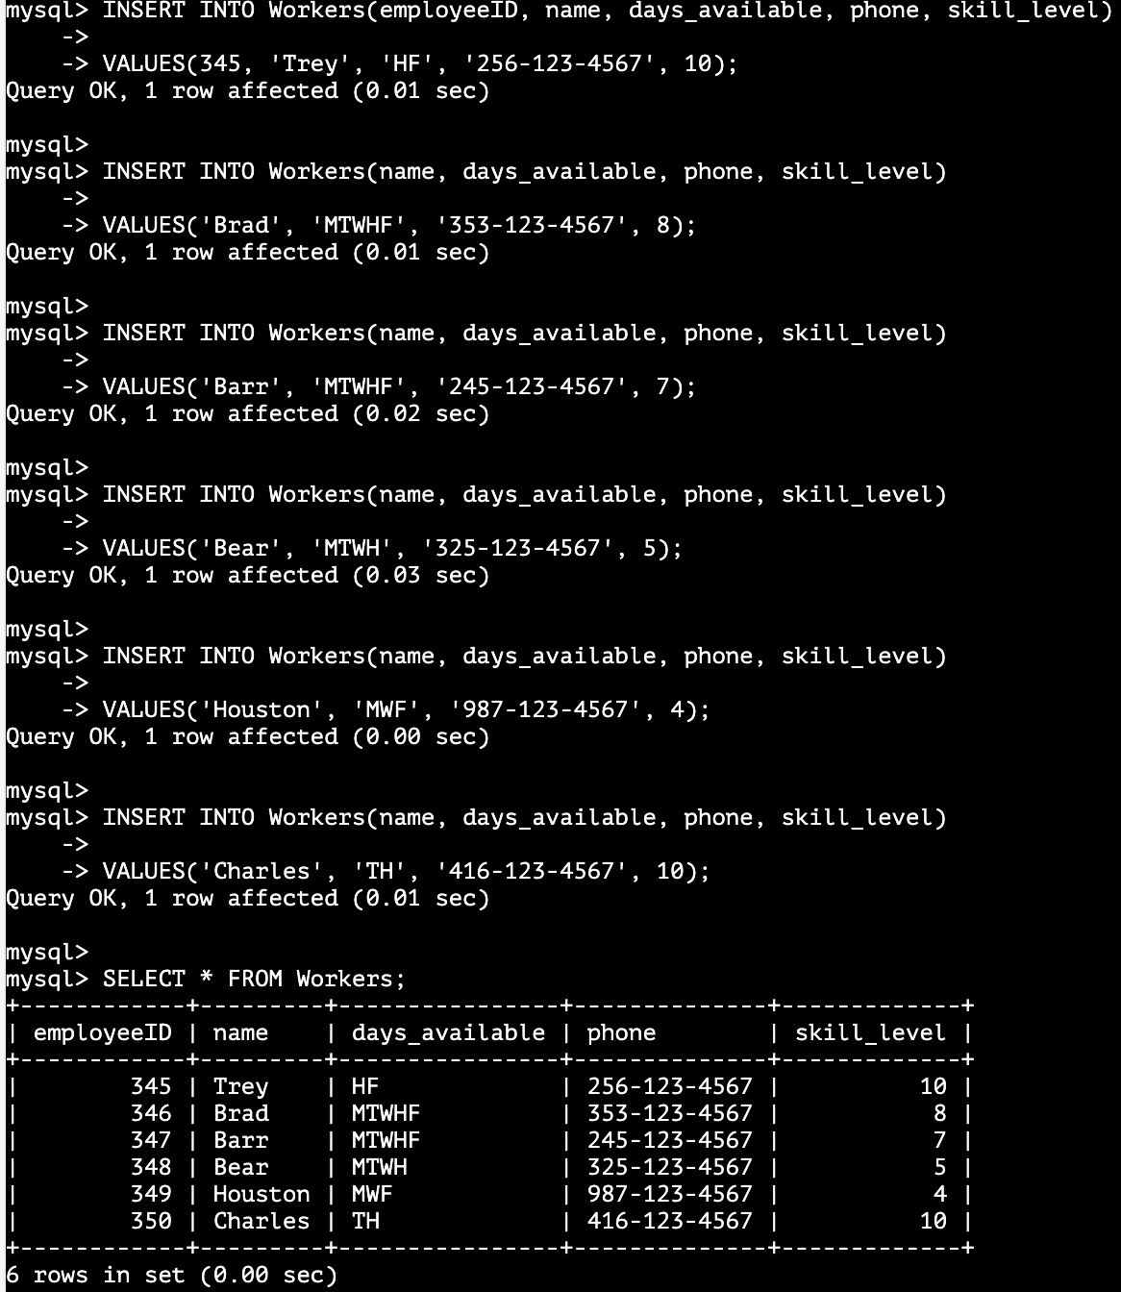

Equipments:

CREATE TABLE Equipments(type varchar(16) PRIMARY KEY NOT NULL,

number_available varchar(11) NOT NULL, skill_level int NOT NULL

CHECK (skill_level >= 1 OR skill_level <= 10),

FOREIGN KEY (skill_level) REFERENCES Workers (skill_level));



Inserting Equipments data:

INSERT INTO Equipments(type, number_available, skill_level)

VALUES('mower', 10, 2);

INSERT INTO Equipments(type, number_available, skill_level)

VALUES('blower', 10, 1);

INSERT INTO Equipments(type, number_available, skill_level)

VALUES('string trimmer', 12, 3);

INSERT INTO Equipments(type, number_available, skill_level)

VALUES('edger', 5, 7);

INSERT INTO Equipments(type, number_available, skill_level)

VALUES('hedge trimmer', 5, 5);

INSERT INTO Equipments(type, number_available, skill_level)

VALUES('chainsaw', 3, 10);

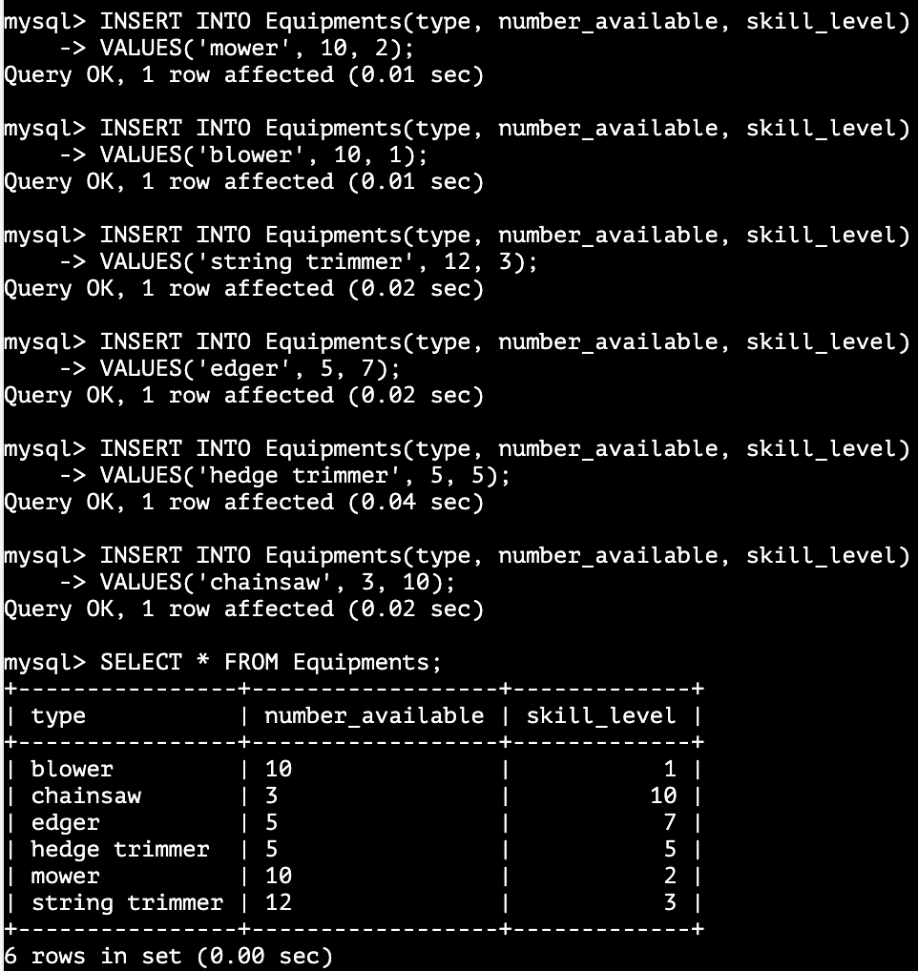

Customers:

CREATE TABLE Customers(customerID int PRIMARY KEY

NOT NULL AUTO_INCREMENT CHECK (customerID >= 100),

name varchar(25) NOT NULL, address varchar (100) NOT NULL,

phone varchar(16) NOT NULL,

FOREIGN KEY (name) REFERENCES Jobs (customer_name));

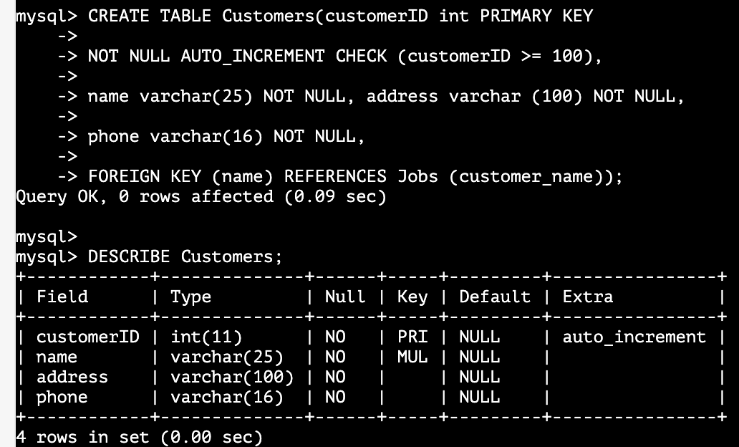

Inserting Customers data:

INSERT INTO Customers(customerID, name, address, phone)

VALUES(1000, 'Melissa', '11 Wood Avenue Muscle Shoals', '258-123-4567');

INSERT INTO Customers(name, address, phone)

VALUES('Chez', '81 Weston Drive Tuscumbia', '858-123-4567');

INSERT INTO Customers(name, address, phone)

VALUES('Obi', '1 Mesa Street Temecula', '619-123-4567');

INSERT INTO Customers(name, address, phone)

VALUES('Noble', '71 Fallbrook Street Temecula', '951-123-4567');

INSERT INTO Customers(name, address, phone)

VALUES('Fox', '91 Charleston Street San Diego', '751-123-4567');



Jobs:

CREATE TABLE Jobs(jobID int PRIMARY KEY

NOT NULL AUTO_INCREMENT CHECK (jobID >= 100),

customer_name varchar(25) NOT NULL, type_of_equipment varchar(16)

NOT NULL, numbers_of_workers int NOT NULL

CHECK (numbers_of_workers >= 0), hours_required int NOT NULL

CHECK (hours_required >= 0), day_of_week varchar(11) NOT NULL,

completed tinyint NOT NULL, total_cost double NOT NULL

CHECK (total_cost >= 0));



Inserting Jobs data:

INSERT INTO Jobs(jobID, customer_name, type_of_equipment, numbers_of_workers, hours_required, day_of_week, completed, total_cost)

VALUES(5000, 'Melissa', 'mower', 2, 4, 'M', 1, 76);

INSERT INTO Jobs(customer_name, type_of_equipment, numbers_of_workers, hours_required, day_of_week, completed, total_cost)

VALUES('Chez', 'edger', 2, 3, 'T', 1, 87);

INSERT INTO Jobs(customer_name, type_of_equipment, numbers_of_workers, hours_required, day_of_week, completed, total_cost)

VALUES('Obi', 'blower', 1, 1, 'W', 0, 8.50);

INSERT INTO Jobs(customer_name, type_of_equipment, numbers_of_workers, hours_required, day_of_week, completed, total_cost)

VALUES('Noble', 'chainsaw', 2, 1, 'H', 1, 35);

INSERT INTO Jobs(customer_name, type_of_equipment, numbers_of_workers, hours_required, day_of_week, completed, total_cost)

VALUES('Fox', 'hedge trimmer', 1, 2, 'F', 1, 25);



**4.**

CREATE VIEW DisplayEarning AS

SELECT customer_name AS 'Customer', total_cost AS 'Total Earnings'

FROM Jobs WHERE completed = 1;

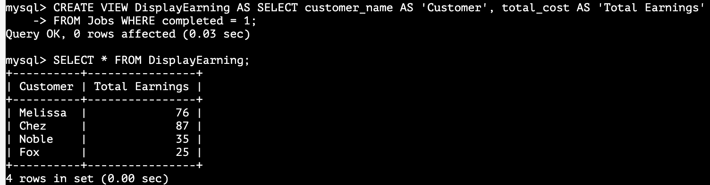

**5.**

First, update the Workers skill_level:

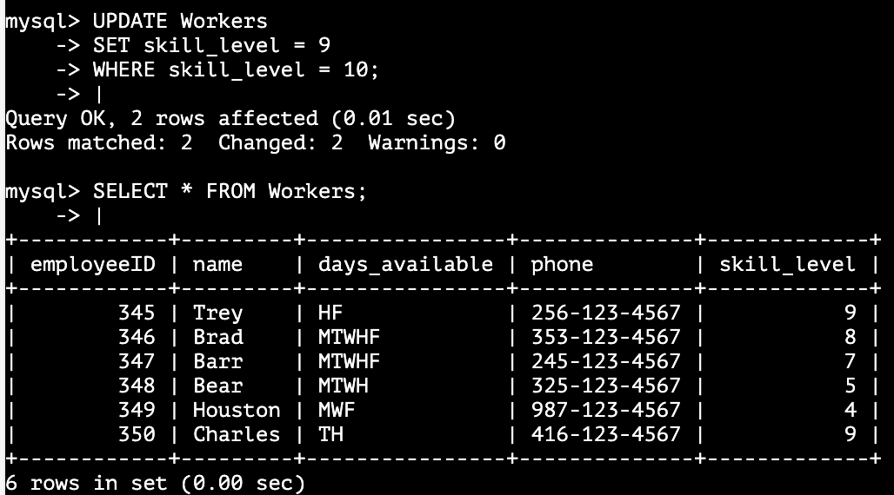

DELIMITER |

CREATE TRIGGER JobsTrigINS

AFTER INSERT ON Jobs

FOR EACH ROW

BEGIN

IF EXISTS (SELECT DISTINCT Equipments.skill_level, Workers.skill_level

FROM Equipments, Workers

WHERE NEW.type_of_equipment = Equipments.type

AND Equipments.skill_level > Workers.skill_level) THEN

DELETE FROM Jobs

WHERE NEW.type_of_equipment = Jobs.type_of_equipment;

END IF;

END; |

Test using ‘chainsaw’



Test using ‘blower’ 



**6.**

DELIMITER |

CREATE TRIGGER JobsEquipTrigUPD

AFTER UPDATE ON Jobs

FOR EACH ROW

BEGIN

IF NEW.type_of_equipment <> OLD.type_of_equipment AND

EXISTS (SELECT DISTINCT Equipments.skill_level, Workers.skill_level

FROM Equipments, Workers

WHERE NEW.type_of_equipment = Equipments.type

AND Equipments.skill_level > Workers.skill_level) THEN

DELETE FROM Jobs

WHERE NEW.type_of_equipment = OLD.type_of_equipment;

ELSEIF NEW.type_of_equipment = OLD.type_of_equipment THEN

INSERT INTO Jobs(jobID, customer_name, type_of_equipment,

numbers_of_workers, hours_required, day_of_week, completed, total_cost)

VALUES(NEW.jobID, NEW.customer_name, NEW.type_of_equipment, NEW.numbers_of_workers, NEW.hours_required, NEW.day_of_week,

NEW.completed, NEW.total_cost);

END IF;

END; |

Before the update:





Updating type of equipment ‘blower’ to ‘chainsaw’



Updating type of equipment ‘chainsaw’ to ‘mower’



**7.**

DELIMITER |

CREATE TRIGGER WorkerTrigUP

BEFORE UPDATE ON Workers

FOR EACH ROW BEGIN

IF NEW.skill_level >= OLD.skill_level THEN

SET NEW.employeeID = NEW.employeeID

AND NEW.name = NEW.name

AND NEW.days_available = NEW.days_available

AND NEW.phone = NEW.phone AND NEW.skill_level = NEW.skill_level;

ELSEIF EXISTS (SELECT employeeID FROM Workers, Equipments

WHERE NEW.skill_level < OLD.skill_level) THEN

DELETE FROM Workers

WHERE NEW.name = Workers.name;

END IF;

END; |

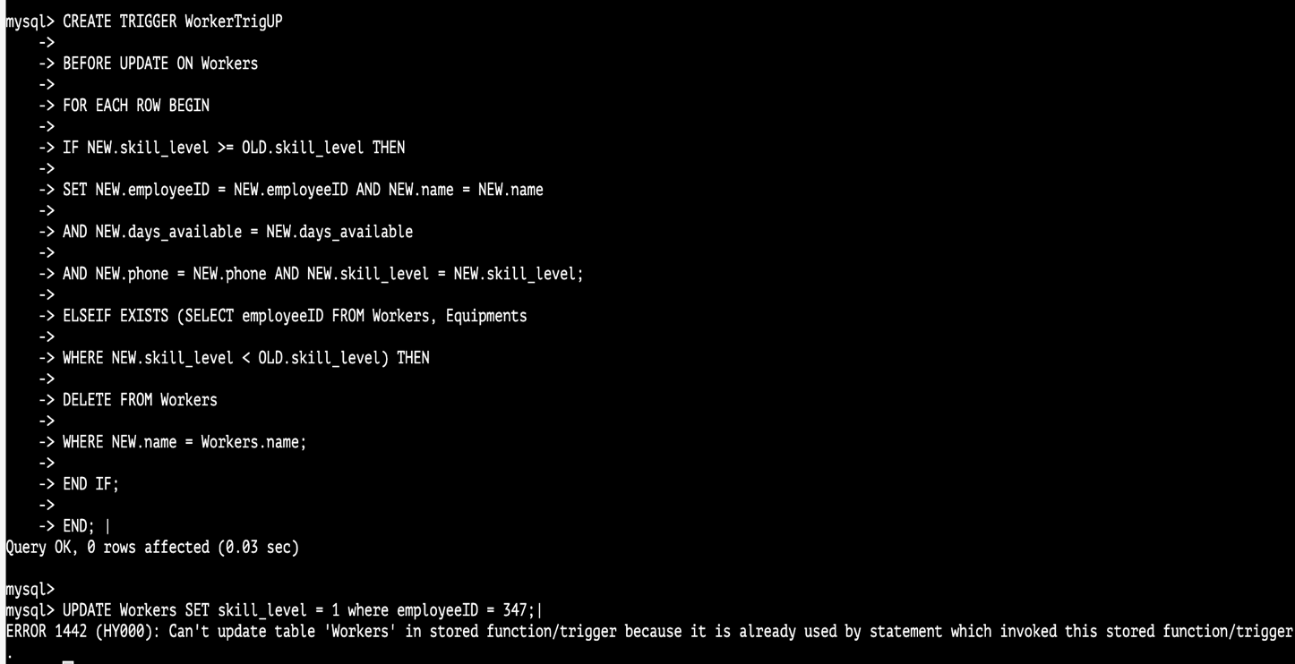



**8.**

DELIMITER |

CREATE FUNCTION newJob (customer varchar(25), day varchar(11), workers int,

equipment varchar(16), hours int) RETURNS int DETERMINISTIC

BEGIN

DECLARE m int;

DECLARE p double;

DECLARE w double;

DECLARE s int;

SET w = (SELECT DISTINCT minWage FROM wages);

SET s = (SELECT Equipments.skill_level FROM Equipments

WHERE equipment = Equipments.type);

IF EXISTS (SELECT DISTINCT Jobs.type_of_equipment FROM Jobs

WHERE day <> Jobs.day_of_week UNION

(SELECT DISTINCT Equipments.type FROM Equipments

WHERE workers <= Equipments.number_available)) THEN

BEGIN

SET p = (((w + s) * hours) * workers);

INSERT INTO Jobs(customer_name, type_of_equipment,

numbers_of_workers, hours_required, day_of_week, completed, total_cost)

VALUES(customer, equipment, workers, hours, day, 0, p);

SET m = (SELECT jobID FROM Jobs WHERE customer_name = customer);

RETURN m;

END;

ELSEIF EXISTS (SELECT DISTINCT Jobs.type_of_equipment FROM Jobs

WHERE day = Jobs.day_of_week UNION

(SELECT DISTINCT Equipments.type FROM Equipments

WHERE workers > Equipments.number_available)) THEN

SET m = 0;

RETURN m;

END IF;

END; |



Jobs before select newJob function:



Jobs after select newJob function

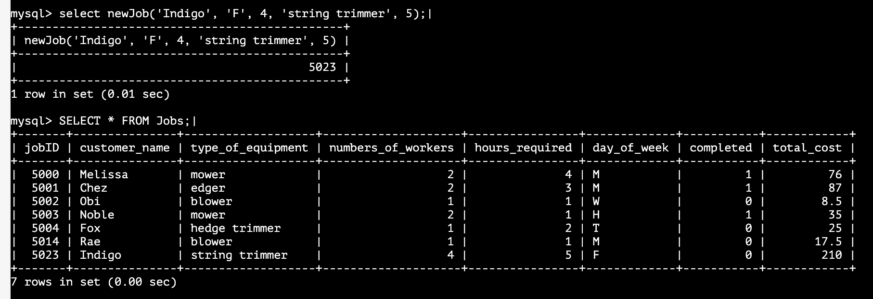

**9.**

The create function would not let me create with no parameters and return no values.

I made a procedure that will be call by “call showJobs.”



DELIMITER |

CREATE PROCEDURE showJobs()

BEGIN

SELECT Jobs.day_of_week, Customers.name, Customers.address,

Customers.phone, Jobs.numbers_of_workers, Jobs.type_of_equipment,

Jobs.hours_required, Jobs.total_cost FROM Customers, Jobs

WHERE Jobs.customer_name = Customers.name

AND Jobs.completed = 0 ORDER BY

FIELD(Jobs.day_of_week, ‘M’, ‘T’, ‘W’, ‘H’, ‘F’);

END; |





Calling showJobs:



**10.**

